Industry Analysis

* **Current trends**
* **Challenges**
* **Opportunities**

We have seen the significant rise in use of customer service chatbot in Automotive Industry in recent years. in this project report we will discuss about the use of chatbot as customer service in Automotive Industry (Water Tunnel Car Wash company) as a reference example. Using chatbot in such industry have provided significant benefits to the owner and has also helped to cover wide range of customers. In this topic we will discuss about the current trends, challenges and opportunities of using chatbots in Automotive industry in more details.

Current trends:

The use of chatbot as a customer service is rising in every industry. chatbots is very popular in healthcare industry, IT industry, tourism and hospitality, finance and business etc. apart from that Automotive industry is not far away from that. Here we will further discuss the current trends of using chatbots as a customer service in Automotive Industry.

1. Personalized customer interactions: Chatbots has been using as a personalized customer interactions in this Industry. automotive industries are implementing GenAI chatbots for highly personalized customer experiences where the personal details of every customer have stored in a system safely. These chatbots analyse the customer data and service history and provide the service recommendations and other useful information.
2. 24/7 availability: the increasing trend of use of chatbots boost because of their availability. They can interact with customers at any time and customers can get update of service availability at any time. Apert from the more interactions with customers also helping the to grow Automotive Industry.
3. Multilingual support: the chatbots who can interact in many languages are in trend in such Industry. This is because such chatbots can cover wide range of customers such as native and non-native speakers from different regions ultimately that helps in grow of Automotive Business.
4. Integration in vehicle system: The system of chatbots can deploy into vehicle systems that helps to find actual update of what’s wrong with the vehicle and what need to be done to repair it. Such kind of chatbots is very useful in finding actual maintenance issues.

Picture below shows clearly how GenAI chatbot works as a customer service in Automotive Industry. In this project we will create a chatbots for customer service in the same format as shown below and deploy it into the website based on Automotive Industry.

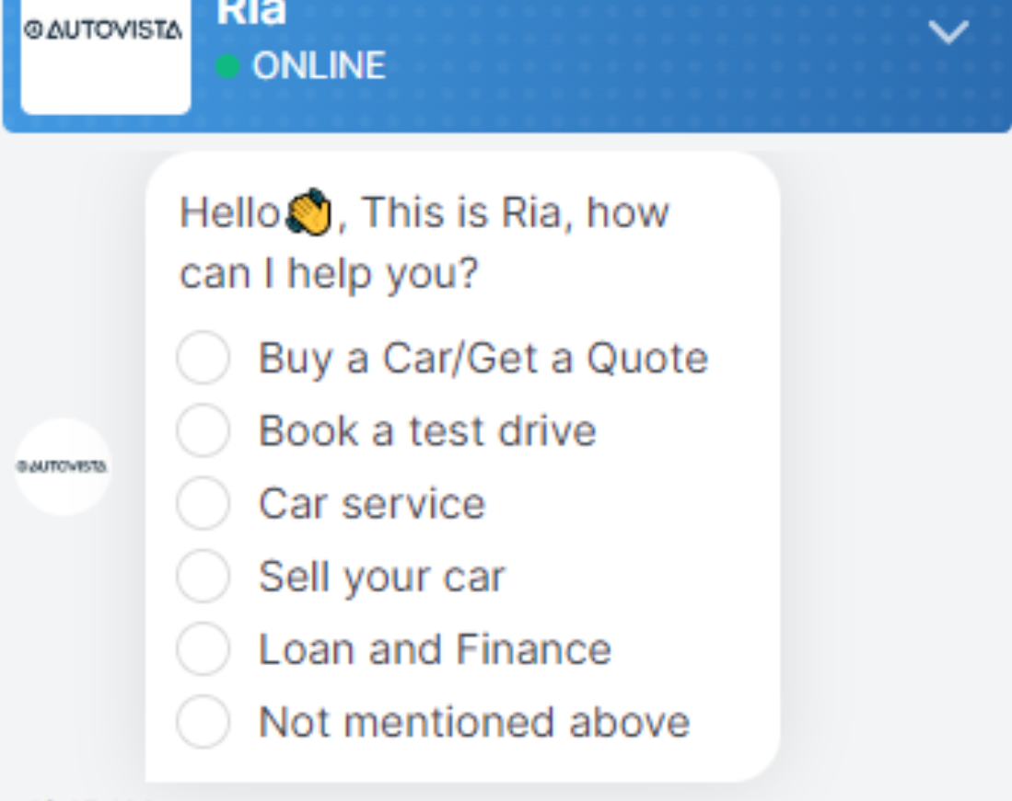

Fig 1: source google

Challenges:

Despite of having very useful benefits of using chatbots as a customer service, we could face some noticeable challenges while implementing it. Here we will discuss about the challenges caused by chatbots, that we need to be aware of its implementations.

1. Data privacy and security concerns: the first and main challenges while implementing chatbots as a customer service is data privacy and security. While interacting with customers, the customers may need to provide their personal information to the chatbots that stored into the chatbots system. Such information need to keep safe and secrete for customers privacy. Sometimes the third person steal the personal information from such type of chatbots system.
2. Accuracy and reliability: Another challenge arises while using chatbots is accuracy and reliability. The information provided by the chatbots must be accurate and reliable to customers. Sometimes chatbots may not provide information for complex queries that creates dissatisfactions to customers and reliability issues.
3. Difficulties in Integrations with system: Integrations of chatbots systems into companies’ system may need expertise into the same field and may have expensive in the budget. While integrating chatbots into companies’ system the chatbot can excess the private information of company that may arise the big concerns on data security.
4. Continuous learning and updating: the chatbots may need to update regularly otherwise they may provide outdated and misinformation to customers. The update could have been new programming systems, features, update upon company such as companies’ new police, vehicle information, customers benefit etc. That may have costly as well as may create conflict of interest among stakeholders either it is implement or not.

Opportunities:

Despite of having some challenges on implementing customer service chatbots it provides great opportunities to grow business. Here are some opportunities provided by chatbots after its implementations:

1. Improve customer interactions: as we discussed above about its availability. It is available all-time times and customers can interact at any time that helps in covering more customers, that helps in business growth. Apart from that chatbots can analyse customers preferences, interest and their behaviours through interacting them, analysing data stored in system industries can create a market strategy and improve in their service and product.
2. Cost reduction: implementing chatbots can provide an opportunity of reducing cost. Chatbots can handle large number of enquiries in a significant time that may take long time for human for the same work. So that other people can handle other more complex task.
3. Expansion into new market: as we discussed chatbots can interact with many customers in many languages that help in expanding the business into new market easily. Chatbots can handle the enquiries upon car dealership, maintenance, pricing and troubleshooting etc which more than enough to grow business into new market.

Figure below shows the clear information of benefits of using Chatbots in Automotive Ibndustry.

Fig 2: source google